NAME: NISHA K

REG:NO: 192411231

EXP:NO: 2

Create a simple cloud software application for Flight Reservation System using any Cloud Service Provider to demonstrate SaaS.

**AIM:**

To design and deploy a simple cloud-based Flight Reservation System using a cloud service provider (Zoho Creator) and demonstrate the concept of Software as a Service (SaaS).

**PROCEDURE:**

1. Log in to Zoho.com and access the Zoho Creator platform.
2. Create a new application and provide a suitable name (e.g., Flight Reservation System).
3. Design the application by adding necessary forms (Flight details, Passenger registration, Booking) and reports for managing reservations.
4. Configure and deploy the application on the Zoho cloud platform.
5. Share the application link with users, enabling them to access the service directly via the internet.

**OUTPUT:**

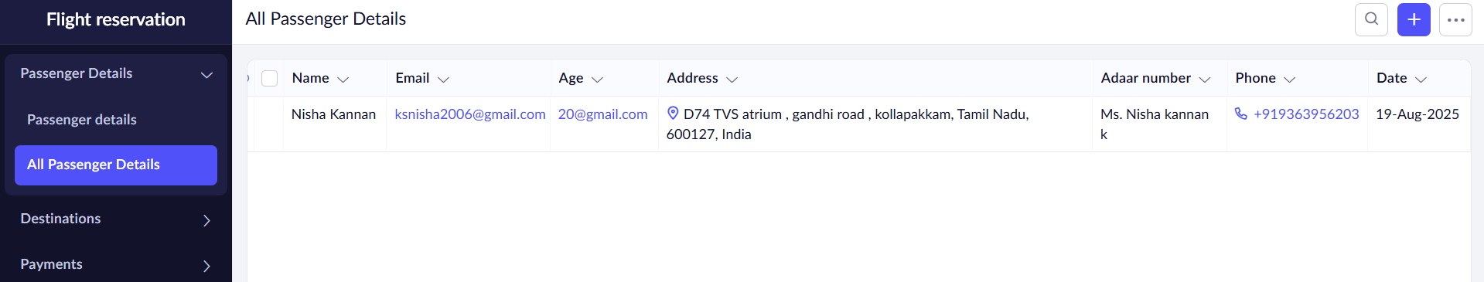

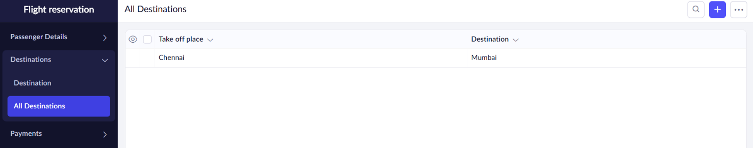

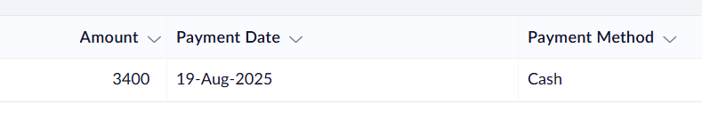

**RESULT:**

A Flight Reservation System was successfully created and deployed using Zoho Creator.  
Users can book flights online through the cloud without installing any software, thereby demonstrating the SaaS model